A COMPARISON OF THE MARS SOUTH POLAR RECESSION RATES BETWEEN 1999 AND 2001. . T. N. Titus¹ and H. H. Kieffer¹, ¹USGS, 2255 N. Gemini Dr., Flagstaff, AZ 86001.

Introduction: Between one-quarter and one-third of the Martian atmosphere is cycled through the polar caps, condensing out in the fall and winter, and sublimating in the spring and summer. Analysis of Viking Lander pressure curves suggest the balance between sublimation and condensation rates varies little from year to year, even for years with global dust storms [1]. This would suggest that the polar caps recession and growth rates do not have interannual variations. However, telescopic and spacecraft observations of the polar caps do show interannual differences, at least on the local scale.[2, 3]
The Mars Global Surveyor (MGS) monitored the recession of the south polar in 1997, 1999, and 2001. 1999 was a year free of global dust storms while 2001 had one of the largest observed global dust storms in observed Martian history [4]. Mars Optical Camera (MOC) observations have been used to compare the southern recession rate in the visual [5]. However, in the visible it is difficult to distinguish between exposed soil and dark CO₂ [6]. We avoid this difficulty by using temperatures derived from Thermal Emissiion Spectrometer (TES) data to compare recession rates.
Data Analysis: Kieffer and Titus [6] initially characterized the south polar recession rate in 1997 by fitting an arctangent curve to the temperature rise that occurs when soil is exposed. The inflection point of the arctangent curve was used to parameterize that season (Ls) when all of the CO2 has disappeared, referred to as the CROCUS date. The 1997 analysis used a diurnally corrected 30 μm brightness temperature. For the 1999 and 2001 analysis, the "2 pm" 30 μm brightness temperatures were used. Since 1999 and 2001 data sets were analyzed using the same parameter and the two years represent a clear and a dusty year, we only compare these two years.
For southern spring, we used data from Ls = 180 to Ls = 300 (1999) and Ls = 180 to Ls = 285 (2001). The spectral data was convolved into the T30 synthetic brightness temperature [6, 7]. Observations from each day where rebinned into 60 km x 60 km cells. The arctangent fit was applied to each cell to determine the crocus date. Poor data fits normally occurred in regions where there were never any CO₂ frost or the CO₂ frost was present during the entire season of observation; these results were excluded.
Results: Figures 1 and 2 show the recession of the cap edges as a function of season (L_{s}). Figure 1 is for 1999, a year free of global dust storms. Figure 2 is 2001 when a global dust storm occurred early in the spring season. The crocus map from 2001 is noisier than the 1999 crocus map.
Figure 3 is a difference map between Figures 1 and 2. A 3x3 box filter was applied to remove high frequency spatial noise. There appears to be a correlation between the changes in the cap recession rate and the albedo (Figure 4 and 5). Dark areas, such as the "cryptic" region remain ice covered approximately 4° to 5° of L_{s} longer in 2001 than in 1999. Bright regions, such as the Mountains of Mitchell, disappear approximately 4° to 5° of L_{s} sooner. A 10 day change in the crocus date is equivalent to having approximately 12 cm of ice still on the ground.
These observations are consisted with modeling done by Bonev et al. [8] that shows the sublimation rate of bright regions is increased by additional downwelling thermal radiation from a hot dusty atmosphere. The sublimation rate of dark regions is depressed from a decrease in visible radiation incident on the surface.
References: [1] James, P. B. et al (1992) In Mars, 934-968. [2] James, P. B. et al. (1979) JGR, 84, 2889-2922. [3]James, P. B. et al. (1987) Icarus, 71, 298-305. [4]Christensen, P. R. (2001) DPS, 33, 42.01. [5]James, P. B. et al. (2000) Icarus, 144, 410-418. [6]Kieffer, H. H. et al. (2000) JGR, 105, 9653-9699. [7]Kieffer, H. H. and Titus, T. N. (2001) Icarus, 105, In Press. [8] Bonev, B. et al. (2001) DPS, 33, 27.05.

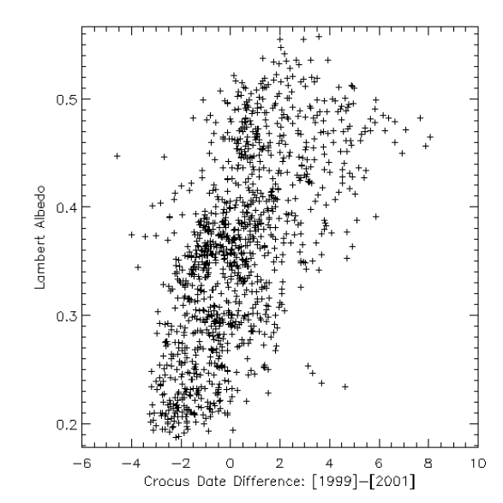
Figure 5: Lambert Albedo vs Crocus date change. The plot shows a corrolation between the change in crocus dates between 1999 and 2001, and the cap albedo at Ls ~ 223°.

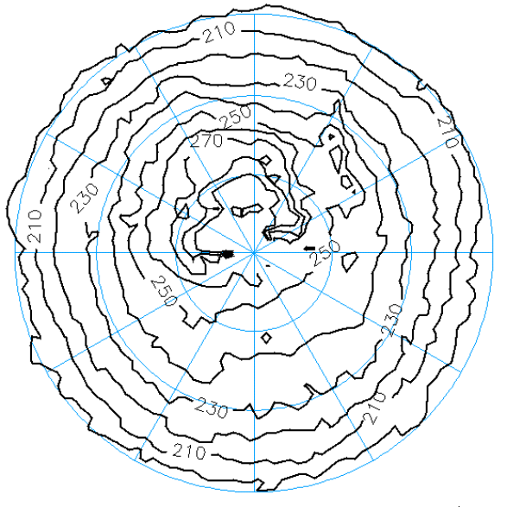
Figure 1: Crocus date map for 1999. The map shows the date at which the CO₂ disappears, outlining the receding cap edge. The top is 0° W longitude and increases in 30° increments counter-clockwise. The latitude lines are in 10° increments, centered on the south pole.
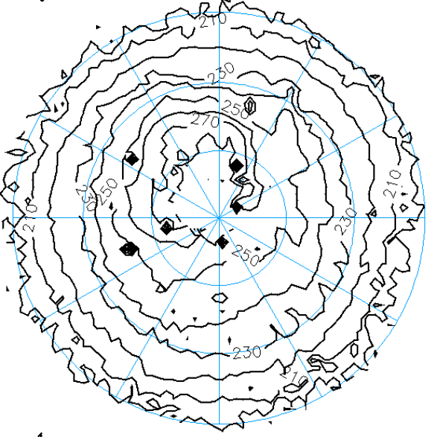
Figure 2: Crocus date map of 2001. This map shows the receding cap edge for 2001. The 2001 map is noisier than the 1999 map. The grid lines are the same as in Figure 1.
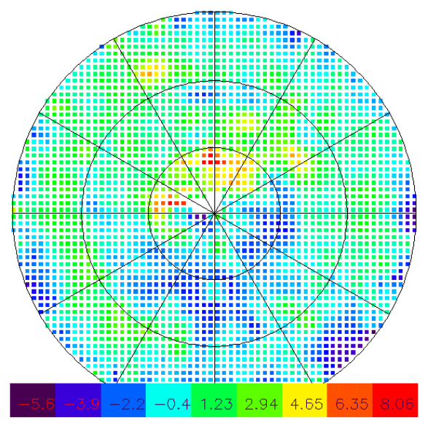Figure 3: Difference map between the crocus dates in 1999 and 2001. The figure shows the difference between the cap recession in 1999 and 2001. Warm colors mean the CO₂ disapeared sooner in 2001 than in 1999. A 3x3 filter was applied to the difference map to remove high frequency noise.
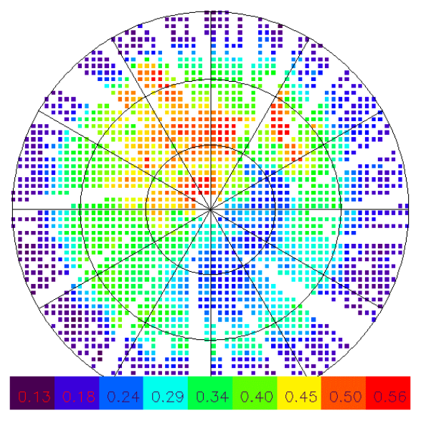Figure 4: TES Lambert albedo map. The figure is a mosaic of TES "2pm" albedo from L_{s}=221°-225°. A comparison to Figure 3 shows a corrolation between albedo and the differences of the cap recession rates between 1999 and 2001. The orientation of the latitude lines are the same as in Figure 1.

